**8-bit full adder project**

**What is full adder?**

*The full adder adds the bits A and B and the carry from the previous column called the carry in (Cin) and the outputs the sum bit (S) and the carry bit called the carry out (Cout). The variable s gives the value of the least significant bit of the sum.*

Full adder truth table

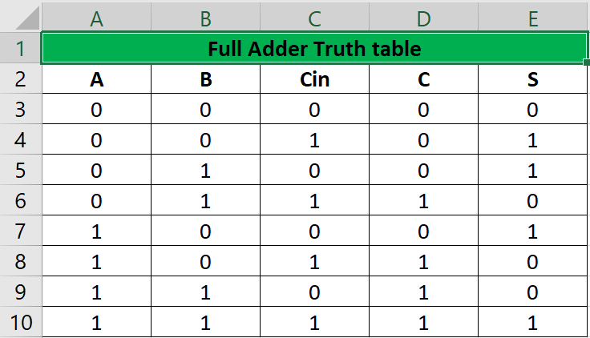

**Carry K-map**

C’

C

C’

B’

A

A’

|  |  |  |  |
| --- | --- | --- | --- |
| 0  0 | 1  0 | 3  1 | 2  0 |
| 4  0 | 5  1 | 7  1 | 6  1 |

B

Carry=BC + AC+AB

Sum K-map

C’

C

C’

A

A’

|  |  |  |  |
| --- | --- | --- | --- |
| 0  0 | 1  1 | 3  0 | 2  1 |
| 4  1 | 5  0 | 7  1 | 6  0 |

B

B’

Sum=A’B’C+AB’C’+ABC+A’BC’

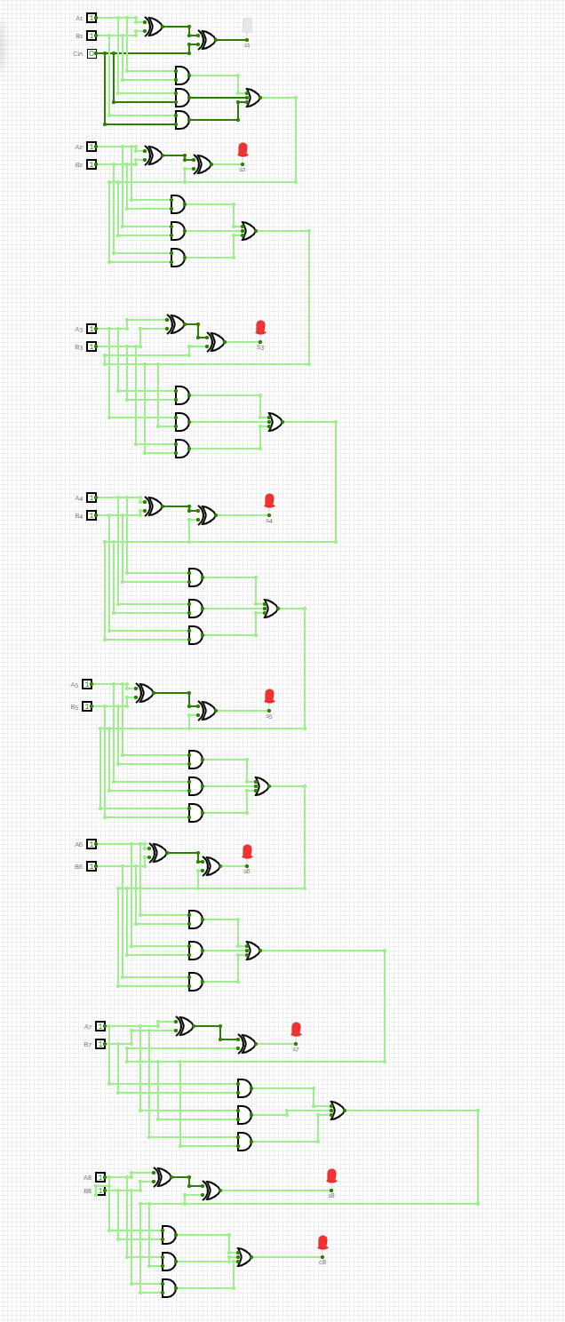Summing

8 bits +8bits

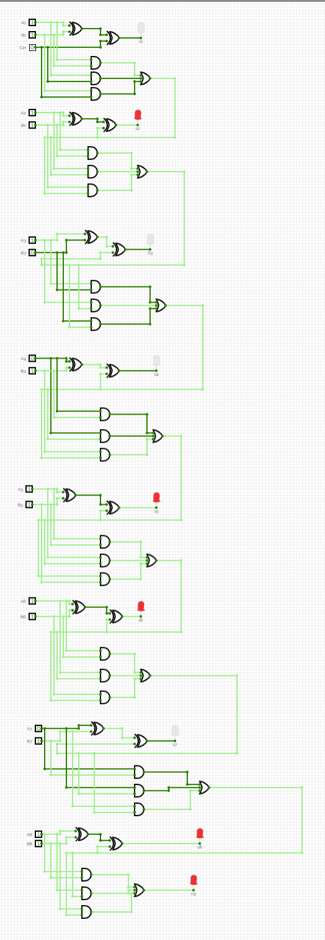sum of

A =10110111

B= 11111011

A+B=110110010

**Hardware simulation**

